Timber Frame Assessment
Date: 6/15/09

Proposal Submitted To:
Saylesville Friends Meeting House
374 Great Road
Lincoln, RI 02865
Project:
East Elevation Timber Frame Assessment

Heritage Restoration, Inc. is dedicated to sustainability, best building practices and enriching the owner to building experience. We are interested in direct and forthright communication with all of our clients. We welcome the opportunity to discuss this Scope of Work and Project Budget with you, so please call us.

HRI believes skilled craftsmanship and best building practices result in sustainability and longevity. HRI’s project goal is to restore the building’s frame to last for centuries and provide a weather tight, functional building envelope. A proper building system respects the original building frame, employs a layered design to shed, not retain water, allows proper air flow, and enables a better, energy efficient system of insulation and plasterboard. Improper installation of the building system, or the use of temporary sealing agents such as caulk, can trap moisture and allow future deterioration to occur. A proper building system shall last for centuries, a moist one can rot in decades.

HRI has the community’s best interest in mind. HRI is mindful of the fiscal burden the repairs cause for the membership, yet also recognizes the responsibility to the future stewardship of the building. HRI shall make every attempt to reach out to the faith based community, as well as the greater Lincoln and RI public community. HRI has several decades of experience in the training and education of the public and the trades, and encourages collaboration that not only enhances the community effort and comradery, but also empowers participants through knowledge and experience. HRI can assist in the development of workshops, such as insulation and plaster, clapboard and siding, etc., that involves community participation to help reduce the project budget.

Existing Conditions Assessment
HRI has completed the assessment of the East Elevation existing conditions. The previous proposal represented an assumption of conditions and subsequent effort to repair the elevation. Since 90% of the elevation’s frame is now exposed, and HRI has a better understanding of the community’s intent and project goals, HRI has completed this East Elevation Timber Frame Assessment. The building has been stabilized and made weather tight, and with monitoring, can last for several months.

HRI has created the following graphic with notes to better illustrate the location of the damage to the timber frame. The conditions are also documented through additional on-site observations, photographs and field drawings. The east elevations observations and existing conditions are as follows:
- The entire 1st floor frame, including the sills and floor joists, were replaced about 1830 or so. The flooring, sheathing, siding, cornerboards, mudboards and some window frames, and all of the sash were also replaced.
- Some of the discovered rot during the 1830 renovations, were left, and have continued to deteriorate until today.
- The upper gable tie beam has been hollowed out from rot, about 5’ long.
- The first south post is rotted from the sill, up about 15 feet. The mortise and tenon connection to the mid girt is rotted.
- The second post is rotted from the sill, up about 19 feet. The mortise and tenon connection to the mid girt is rotted.
- The southern sill is rotted about 13 feet.
- About 20% of the sheathing is rotted.
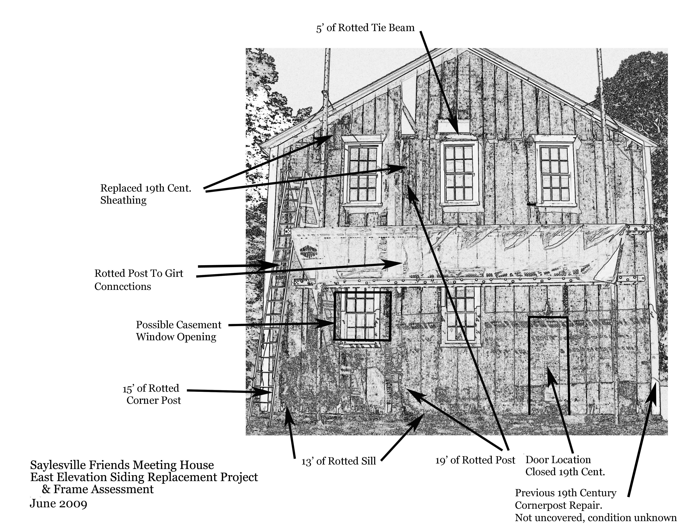

Scope Of Work & Methodology
The final repair methodology still needs to be established by the community to assist in HRI’s overall approach to the project. The methodology defines the final intent and aesthetic, as well as determines the scope of work and assistance by HRI.

This methodology and/or scope of work can be modified. The intent is to repair the timber frame, while trying to save as much intact finishes and materials as possible. The goal is to create a sound structure, a properly crafted, installed, and weather tight exterior envelope, while considering longevity, maintenance and fiscal responsibility for the membership and community. The project methodology shall respect intact building elements where possible, replace the frame using traditional timber framing techniques, while employing modern techniques and materials that mimic traditional textures for cost efficiency.

The proposed scope of work is as follows:
- Complete necessary documentation prior to and during project. Documentation shall include photographs, field sketches and other related project images.
- Remove all of the clapboard siding.
- Repair sheathing using lap joints, epoxy and fasteners where possible. Where repair is not possible, replace sheathing from beam to beam.
- Remove necessary bays of plaster (Post to post, beam to beam) where sheathing is removed. Replace missing plaster areas with 1” of rigid insulation and 1/2 “ plasterboard and plaster skim coat to mimic original plaster finish.
- Repair timber frame where possible, using epoxies, “dutchmans” or replacement.
- Where repair is not feasible, replace timber frame elements using white oak like sized timbers. Use appropriate joinery and/or fastening systems. The timbers shall be circular sawn, with the lambs tongues reproduced where existing.
- Remove 19th century wainscoting on 1st floor. Material may not be salvageable. Replaster wall without wainscoting. Look for clues if there was a baseboard, yet typically the baseboard was applied before plaster in the early 18th century.
- Remove window plank frames and sash where necessary. Remove 19th century trim and save.(?) Original trim could mimic what is on second floor, which is typical of the early 18th century. Windows and trim will be reinstalled as is. Sash will be reinstalled as is. Should the sash and frames be prepped, primed and painted by others?
- Remove 2nd corner board(over 1830’s). Assess original corner board and determine if it should be repaired or reproduced. Reinstall.
- Install new clapboard siding using original lap siding technique and simulated wrought nails. Not only is the clapboard lap appropriate for the 18th century, the technique ensures a weather tight exterior envelope. The siding shall follow the installation patterns on the north elevation.
- Prep remaining trim and paint siding and trim. Window sash excluded.

